

**Online Mobile shop**



 Mahatma Education Society’s

**Pillai College of Arts, Commerce & Science**

# (Autonomous)

**Affiliated to University of Mumbai**

NAAC Accredited 'A' grade (3 cycles) Best College Award by University of Mumbai

ISO 9001:2015 Certified

**CERTIFICATE**

*This is to certify that Mr. /Miss. Shreya Bhattacharjee of* ***T.Y B.Sc. C.S. Semester V*** *has completed the project work in the Subject of* ***ADBMS*** *during the academic year 2022-23 under the guidance of Prof****. _SHUBHANGI PAWAR*** *being the partial requirement for the fulfillment of the curriculum of* ***Degree of Bachelor of Science in Computer Science****,* ***University of Mumbai****.*

***Place:***

***Date:***

*Name & Signature of faculty Name & Signature of external*

*Name & Signature of Co-Ordinator*

Dr. K.M. Vasudevan Pillai Campus, Sector 16, New Panvel - 410206. Tel : 27456100 / 1700 | Fax : 27483208 | Website : [www.pcacs.ac.in](http://www.pcacs.ac.in/)

**ACKNOWLEDEMENT**

The ONLINE MOBILE SHOP MANAGEMENT SYSTEM project is created by Shreya Bhattacharjee student of pillai college Arts,commerce,Science would like to express sincere gratitude towards Computer Science Department

I would like to Thanks lecturer **Miss Shubhangi Pawar** and for constant support during project. Last but not least thanks all my colleagues for being with me throughout the project.

**INDEX**

SR.NO TOPIC SIGN

1. Introduction

2. Objective of Project

3. Description

4. Features

5. Project Category

6. Structure of Program

7. Code of Project

8. Output

**INTRODUCTION**

The topic “online mobile shop” is used to managed the sale and distribution and record of stocks of particular products

ONLINE MOBILE SHOP MANAGEMENT is a project developed to make purchase mobile in an easy way. It also helps us to managed the particular product more efficiently so that it become easy for handling stocks.

**Objective of project**

* Simplify the work
* Make it accessible over net
* Put everything together in one place

**Description**

Online mobile phone shop is meant for the mobile phone shopping on the internet. This application includes the display and purchasing of mobile handsets of different companies. User goes to the online mobile shop website where he gets all the details of mobile . Admin can add, delete, update the mobile.

The main objective behind web site is it provide all the details regarding mobiles ie. mobile name, description,price,model.

**Structure of Program**

Tools/Platform

1. Netbeans 8.2
2. Xampp
3. Glass fish

FRONTEND-BACKEND

* HTML
* CSS
* JSP
* DATABASE(PLSQL)

**THE ONLINE MOBILE SHOP MANAGEMENT SYSTEM INCLUDES**

PROCEDURE:

A procedure is **a group of PL/SQL statements that you can call by name**. A call specification (sometimes called call spec) declares a Java method or a third-generation language (3GL) routine so that it can be called from SQL and PL/SQL. The call spec tells Oracle Database which Java method to invoke when a call is made.

TRIGGERS

A PL/SQL trigger is **a named database object that encapsulates and defines a set of actions that are to be performed in response to an insert, update, or delete operation against a table**. Triggers are created using the PL/SQL CREATE TRIGGER statement.

CURSOR

A cursor is **a pointer to this context area**. PL/SQL controls the context area through a cursor. A cursor holds the rows (one or more) returned by a SQL statement. The set of rows the cursor holds is referred to as the active set.

FUNCTION

Similar to a procedure, a PL/SQL function is **a reusable program unit stored as a schema object in the Oracle Database**. The following illustrates the syntax for creating a function: CREATE [OR REPLACE] FUNCTION function_name (parameter_list) RETURN return_type IS. [declarative section]

Code of project

ADD.JSP

<%@page contentType="text/html" pageEncoding="UTF-8"%>

<%@page import="java.sql.*" %>

<!DOCTYPE html>

<html>

<head>

<meta http-equiv="Content-Type" content="text/html; charset=UTF-8">

<title>Add Mobile</title>

</head>

<body>

<%

try{

String url = "jdbc:mysql://localhost:3306/mobile";

String user = "root";

String pass = "";

Class.forName("com.mysql.jdbc.Driver");

Connection con = DriverManager.getConnection(url, user, pass);

CallableStatement add_mobcs = con.prepareCall("{call addmobile(?,?,?,?,?)}");

add_mobcs.setInt(1,Integer.parseInt(request.getParameter("id")));

add_mobcs.setString(2,request.getParameter("name"));

add_mobcs.setString(3,request.getParameter("description"));

add_mobcs.setInt(4,Integer.parseInt(request.getParameter("price")));

add_mobcs.setString(5,request.getParameter("model"));

add_mobcs.execute();

out.print("<script>");

out.print("alert('Mobile Added Successfully')");

out.print("locations='addmobile.jsp");

out.print("</script>");

out.print("Success");

response.sendRedirect("show.jsp");

}

catch(Exception e) {

out.println(e.getMessage());

}

%>

</body>

</html>

Add mobile.jsp

<%@page contentType="text/html" pageEncoding="UTF-8"%>

<!DOCTYPE html>

<html>

<head>

<style>

form{

*width*: 350px;

*height*: 390px;

*background*: linear-gradient(to top,rgb(248, 248, 248)100%,rgb(243, 241, 241)9);

*position*: absolute;

*top*: 100px;

*right*: 450px;

*border-radius*: 10px;

*padding*: 25px;

}

h3{

*color*: white;

}

body {

*background-image*: url("phone.jpg");

*background-color*: #cccccc;

*background-repeat*: no-repeat;

*background-size*: 100%;

}

</style>

<meta http-equiv="Content-Type" content="text/html; charset=UTF-8">

<title>Add Mobile</title>

</head>

<body>

<div class="form">

<form method="post" action="add.jsp">

<h3>Mobile Id: <input type="text" name="id" placeholder="ID"><br></h3>

<h3>Mobile Name: <input type="text" name="name" placeholder="Name"><br></h3>

<h3>Mobile Description: <input type="text" name="description" placeholder="Description"><br></h3>

<h3>Mobile Price: <input type="text" name="price" placeholder="Price"><br></h3>

<h3>Mobile Model: <input type="text" name="model" placeholder="Model"><br></h3>

<input type="submit" value="ADD">

</div>

</form>

</body>

</html>

Delete.jsp

<!DOCTYPE html>

<html>

<head>

<style>

form{

*width*: 350px;

*height*: 390px;

*background*: linear-gradient(to top,rgb(248, 248, 248)100%,rgb(243, 241, 241)9);

*position*: absolute;

*top*: 100px;

*right*: 450px;

*border-radius*: 10px;

*padding*: 25px;

}

h3{

*color*: white;

}

body {

*background-image*: url("phone.jpg");

*background-color*: #cccccc;

*background-repeat*: no-repeat;

*background-size*: 100%;

}

</style>

<meta http-equiv="Content-Type" content="text/html; charset=UTF-8">

<title>Delete Product</title>

</head>

<body>

<div class="form">

<form action="delete.jsp">

<h3>Mobile Id: <input type="text" name="mid" placeholder="ID"><br></h3>

<input type="submit" value="DELETE">

</div>

</form>

</body>

</html>

Delete.jsp

<%@page contentType="text/html" pageEncoding="UTF-8"%>

<%@page import="java.sql.*" %>

<!DOCTYPE html>

<html>

<head>

<meta http-equiv="Content-Type" content="text/html; charset=UTF-8">

<title>Delete Mobile</title>

</head>

<body>

<%

try{

String url = "jdbc:mysql://localhost:3306/mobile";

String user = "root";

String pass = "";

Class.forName("com.mysql.jdbc.Driver");

Connection con = DriverManager.getConnection(url, user, pass);

CallableStatement delete_mobcs = con.prepareCall("{call deletemobile(?)}");

delete_mobcs.setInt(1,Integer.parseInt(request.getParameter("mid")));

delete_mobcs.execute();

out.print("<script>");

out.print("alert('Mobile Deleted Successfully')");

out.print("locations='deletemobile.jsp");

out.print("</script>");

out.print("Success");

response.sendRedirect("show.jsp");

}

catch(Exception e) {

out.println(e.getMessage());

}

%>

</body>

</html>

INDEX.HTML

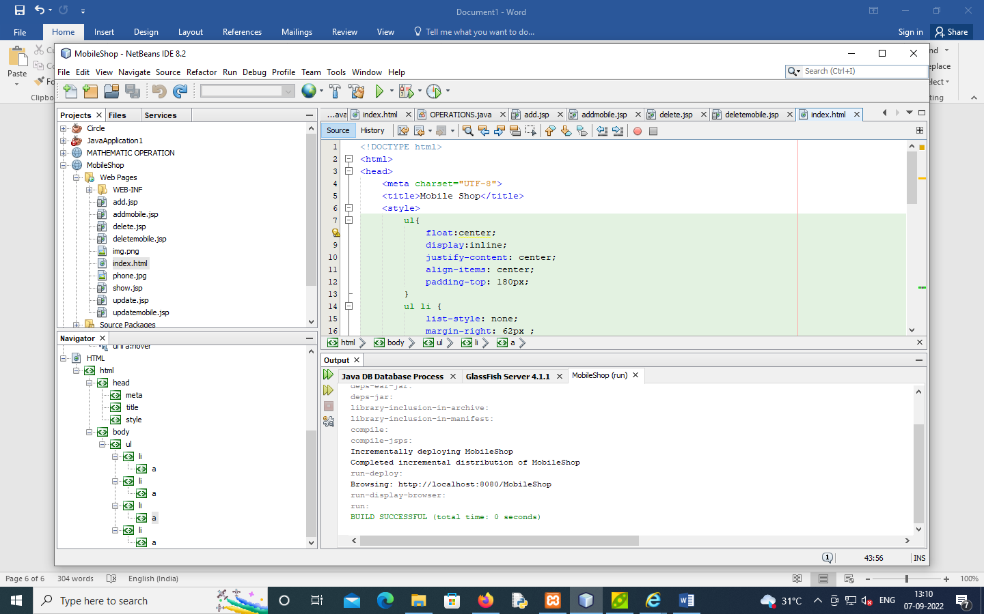

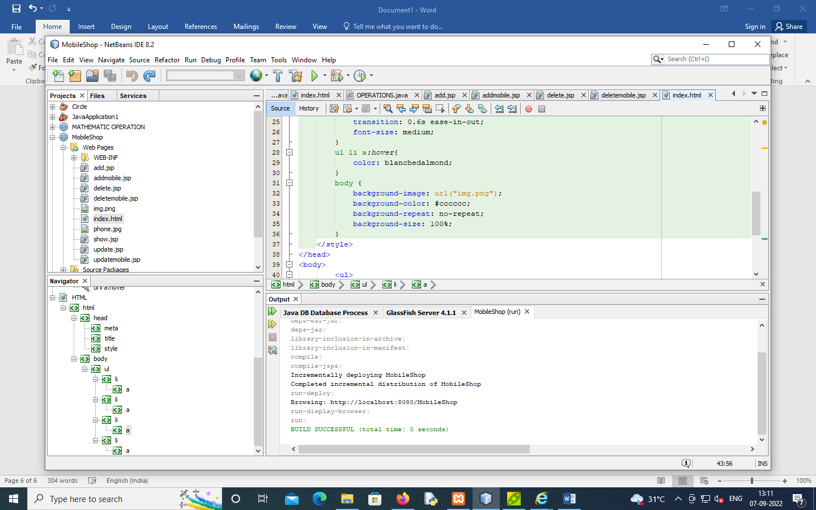

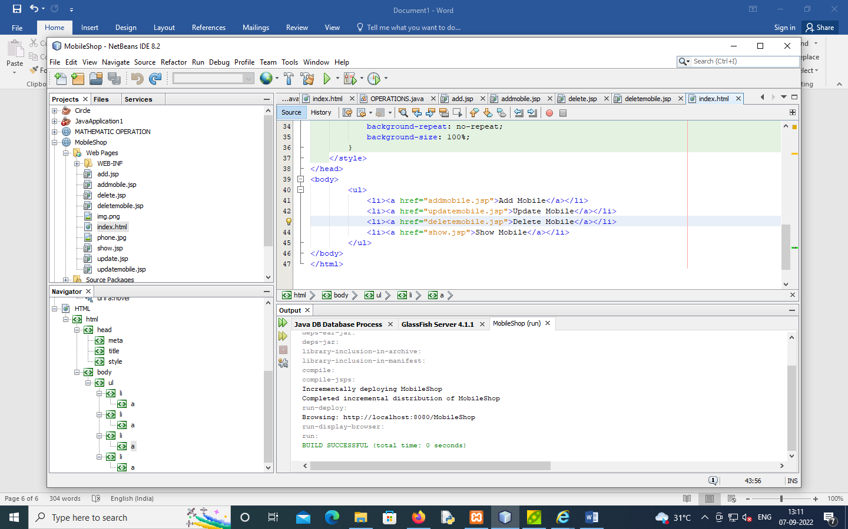

FUNCTION

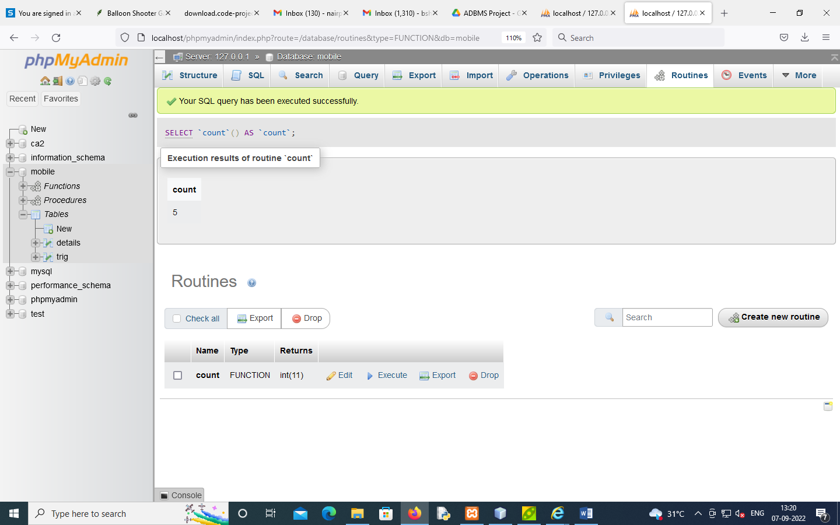

Procedures

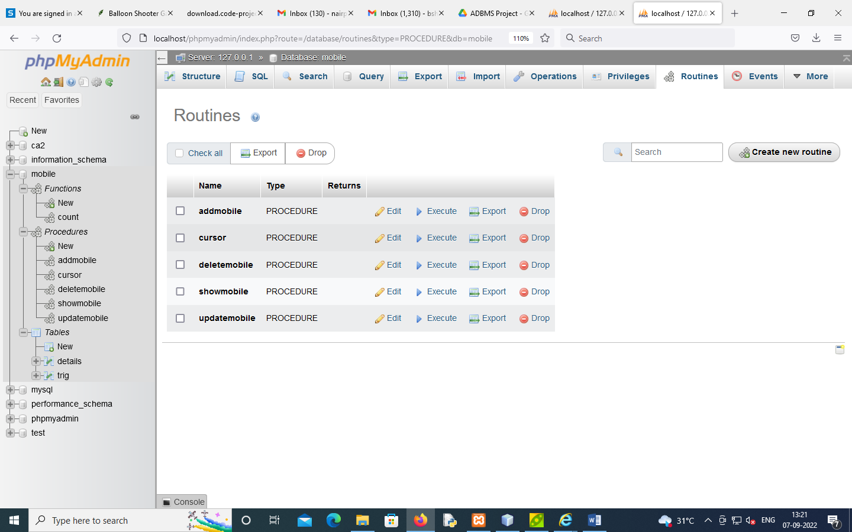

**ADD MOBILE**

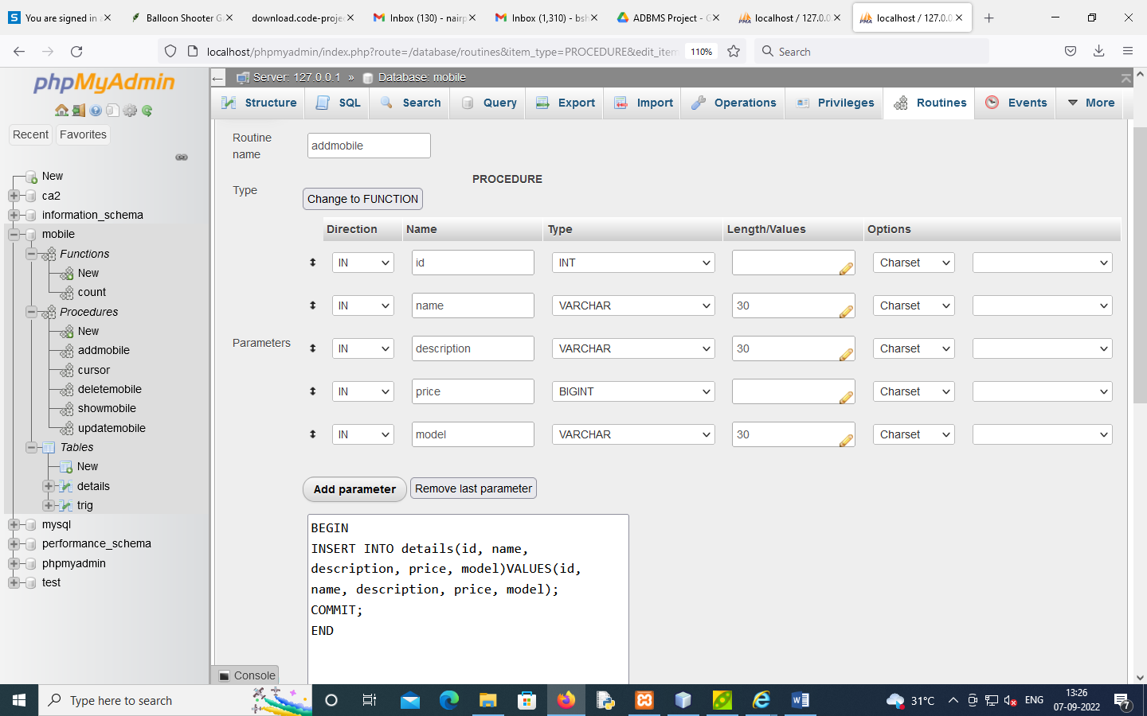

**DELETE MOBILE**

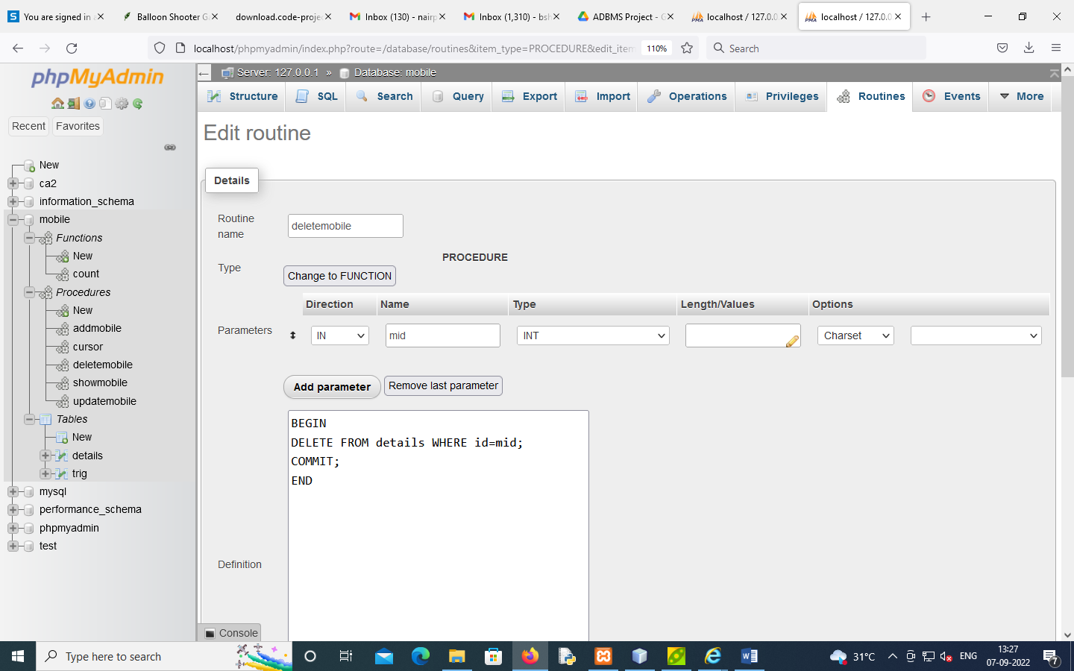

**UPDATE MOBILE**

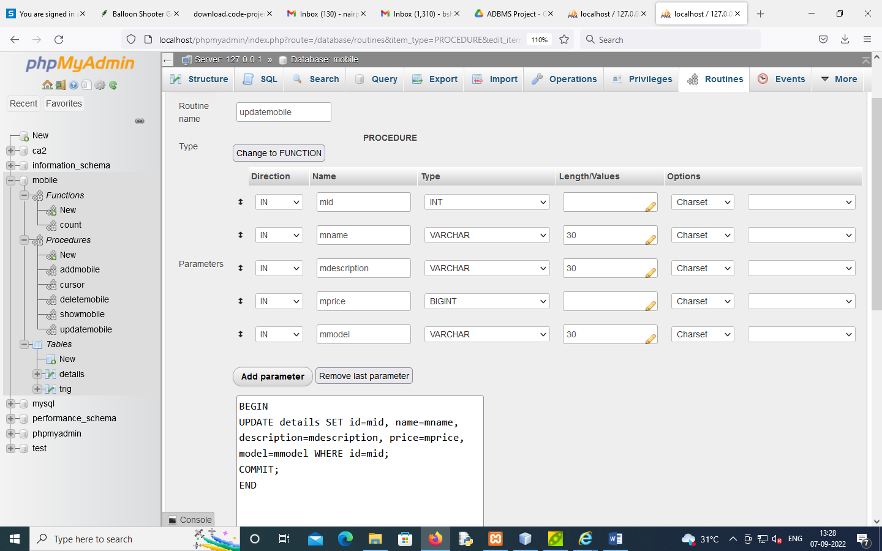

**SHOW MOBILE**

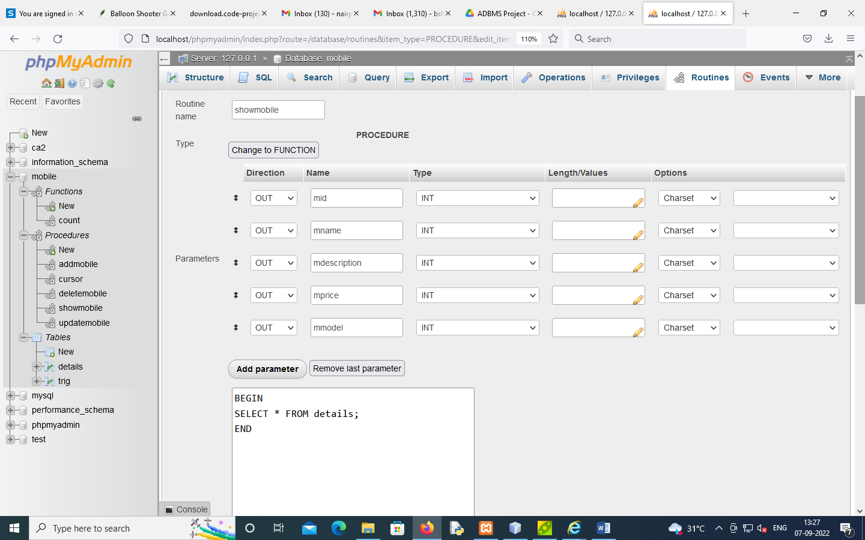

**CURSOR**

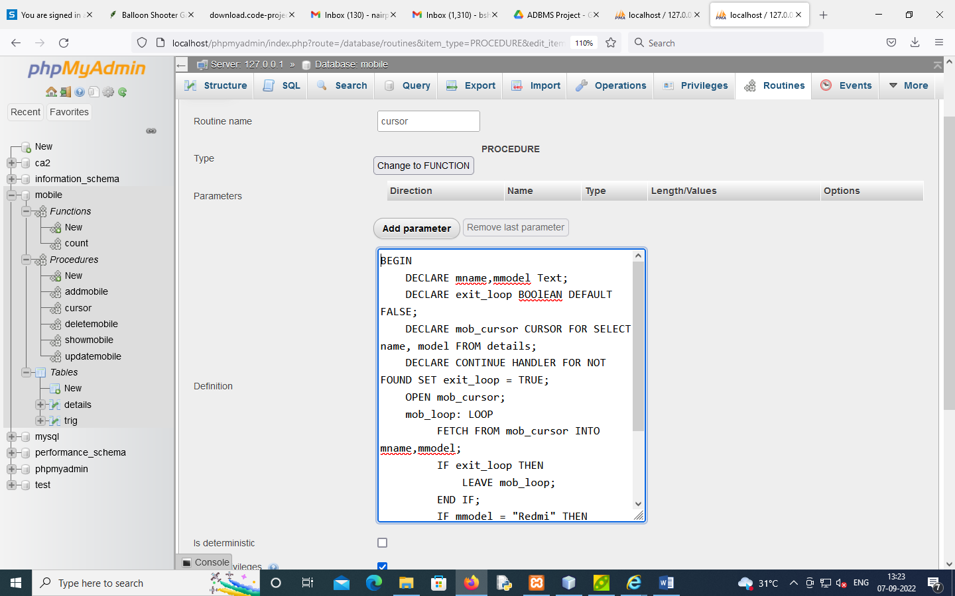

**TRIGGER**

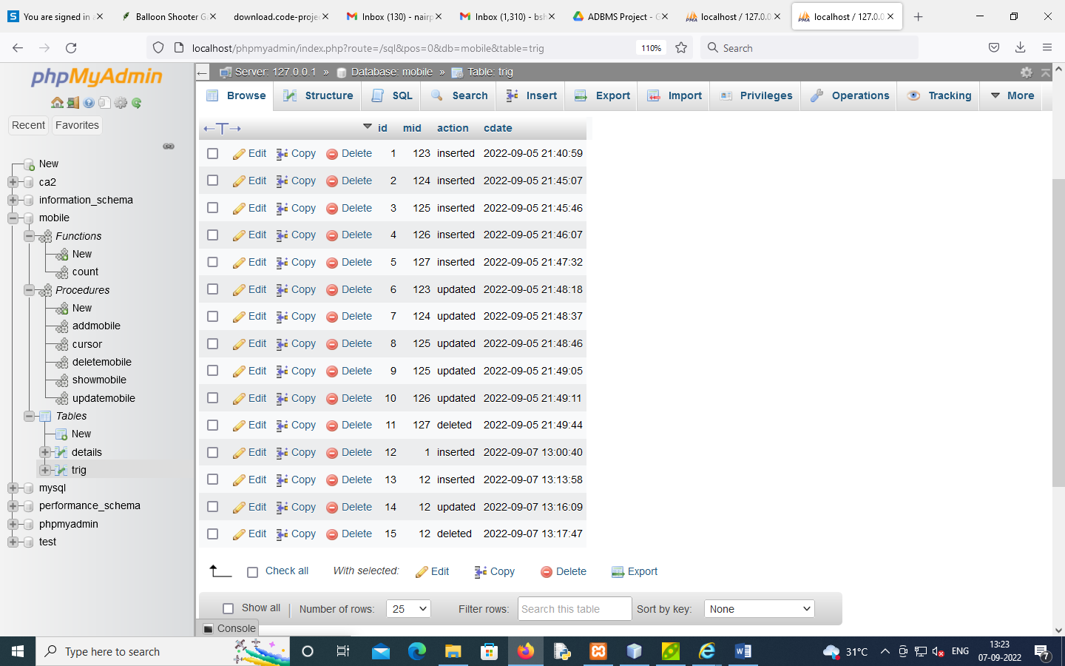

**DETAILS OF PHONE**

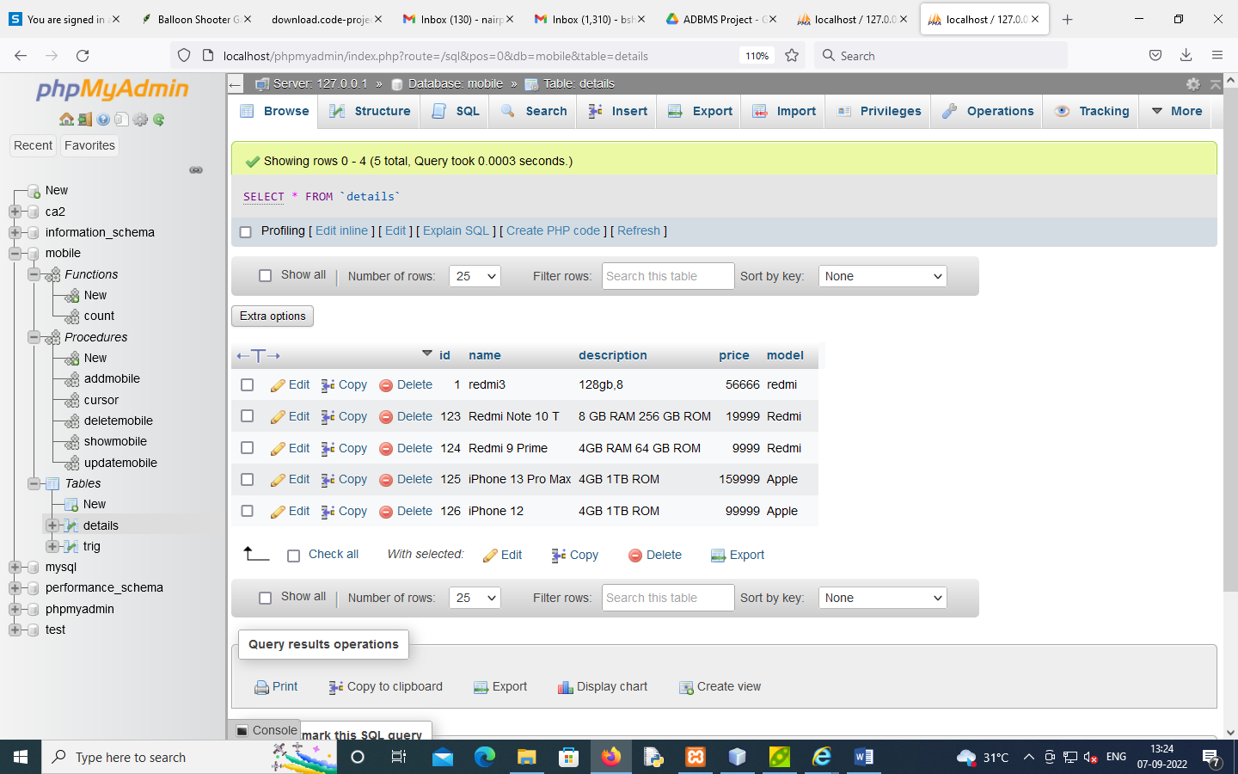

**OUTPUT**

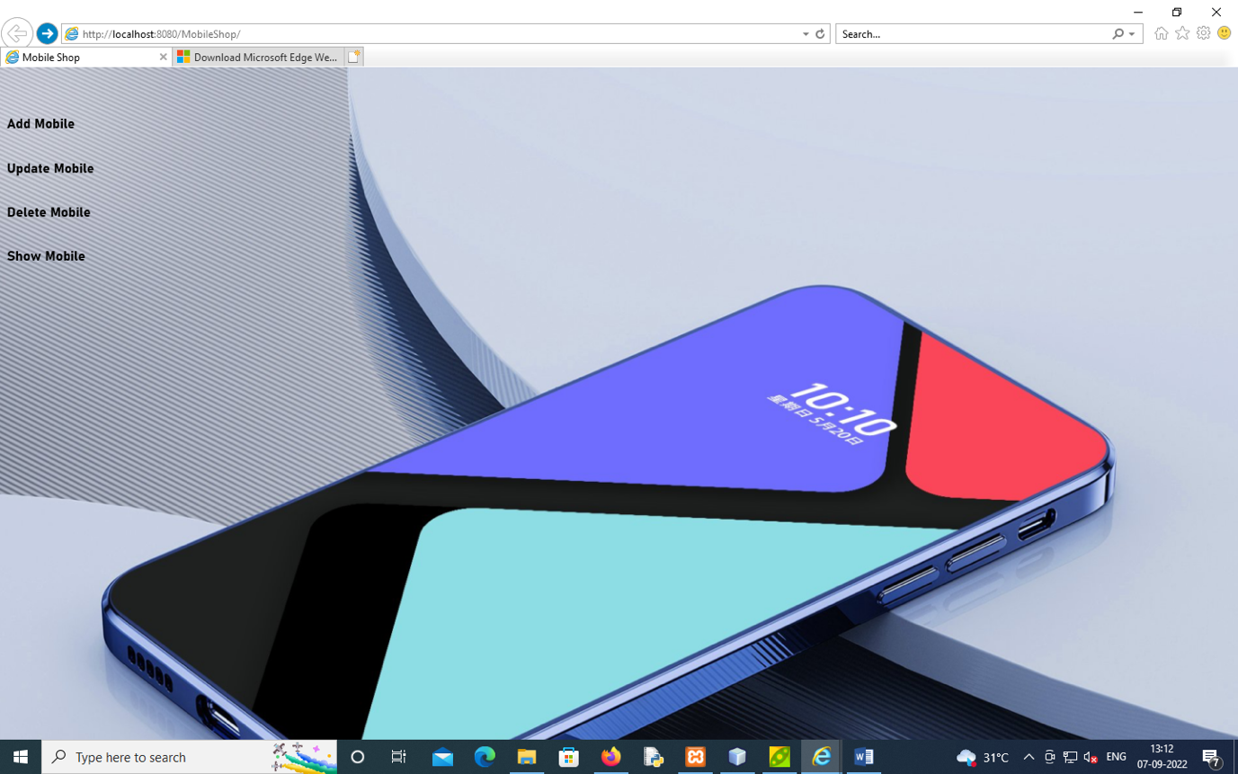

ADD MOBILE

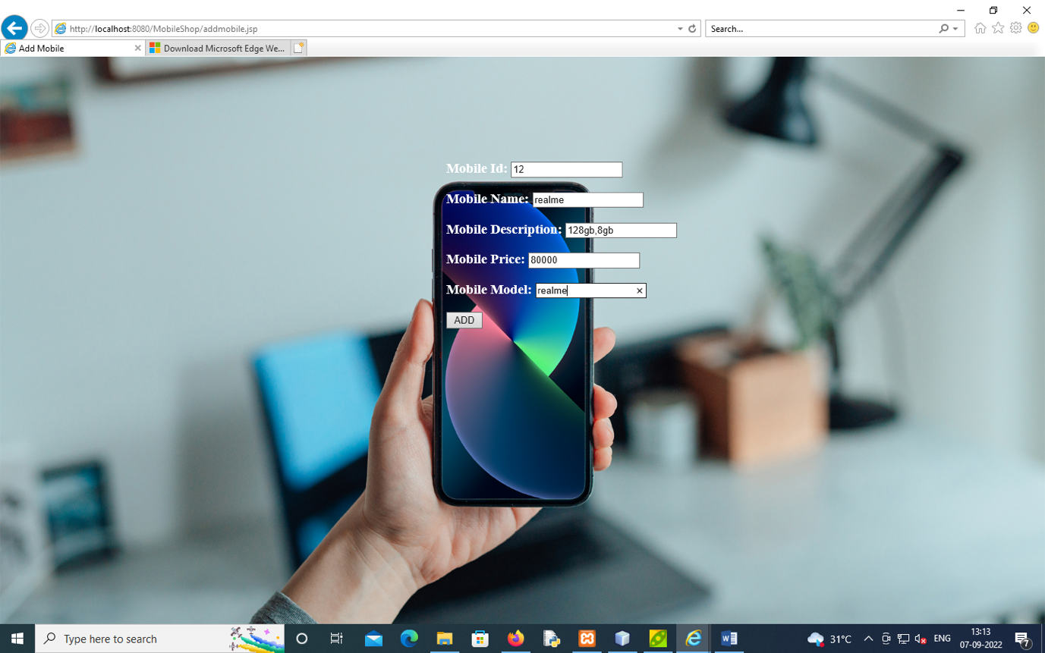

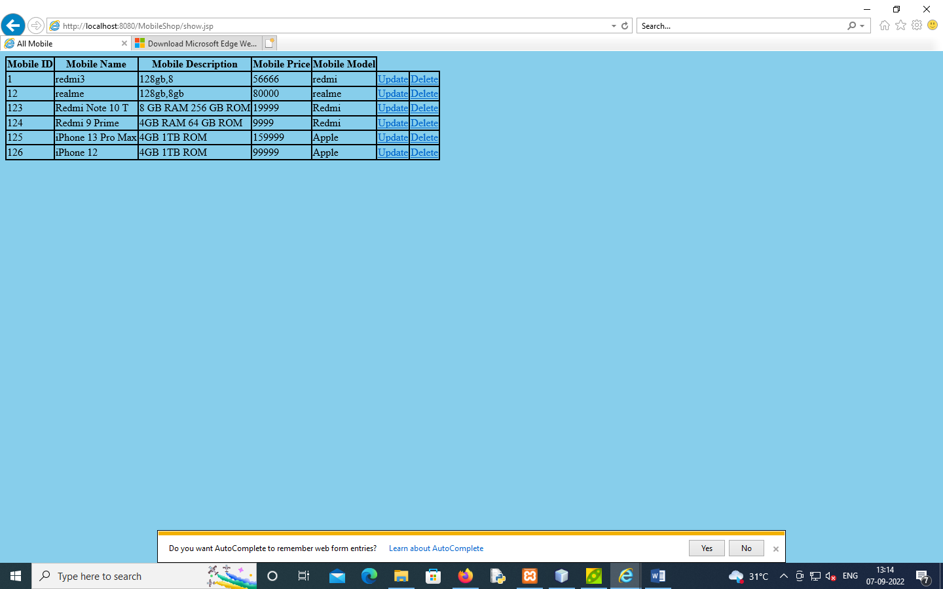

**UPDATE MOBILE**

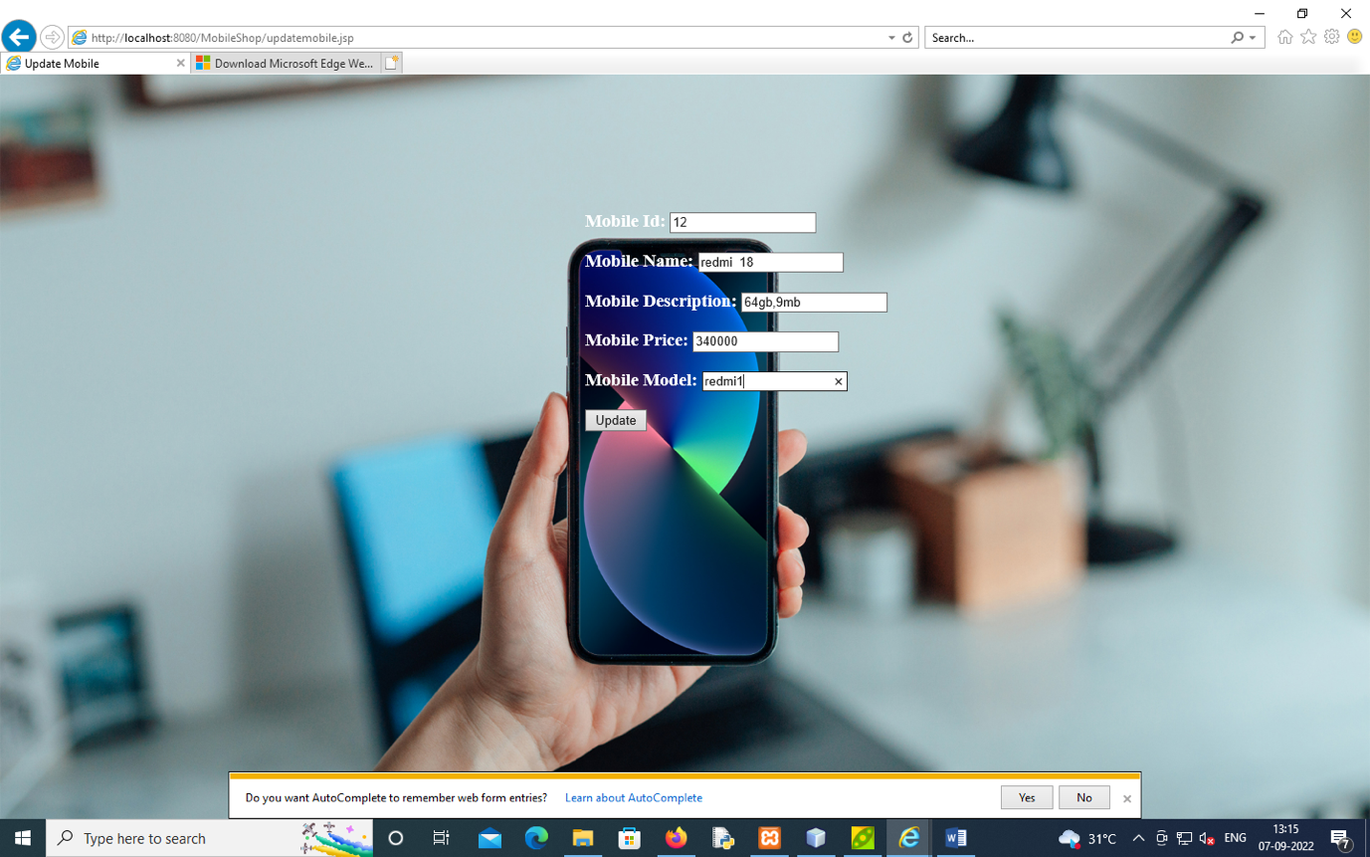

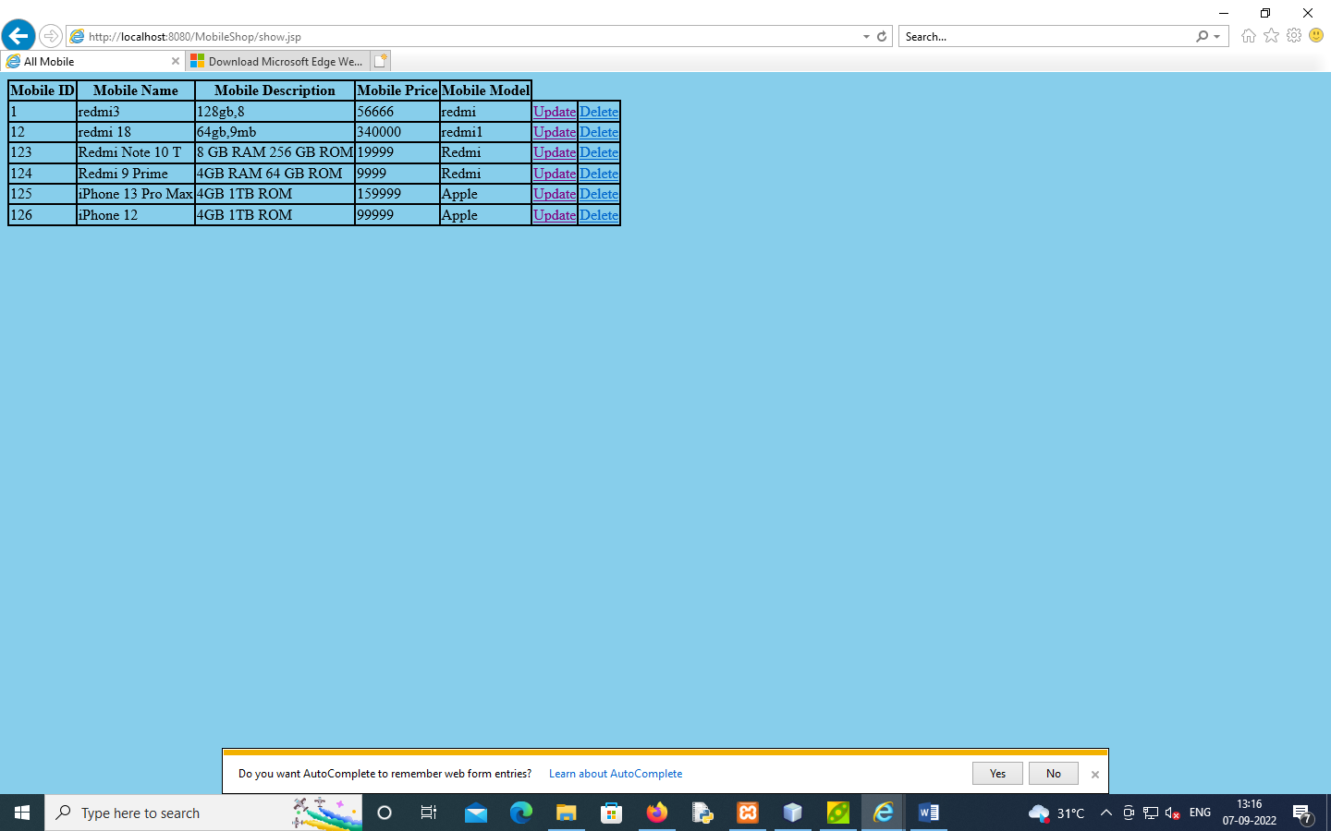

**DELETE MOBILE**

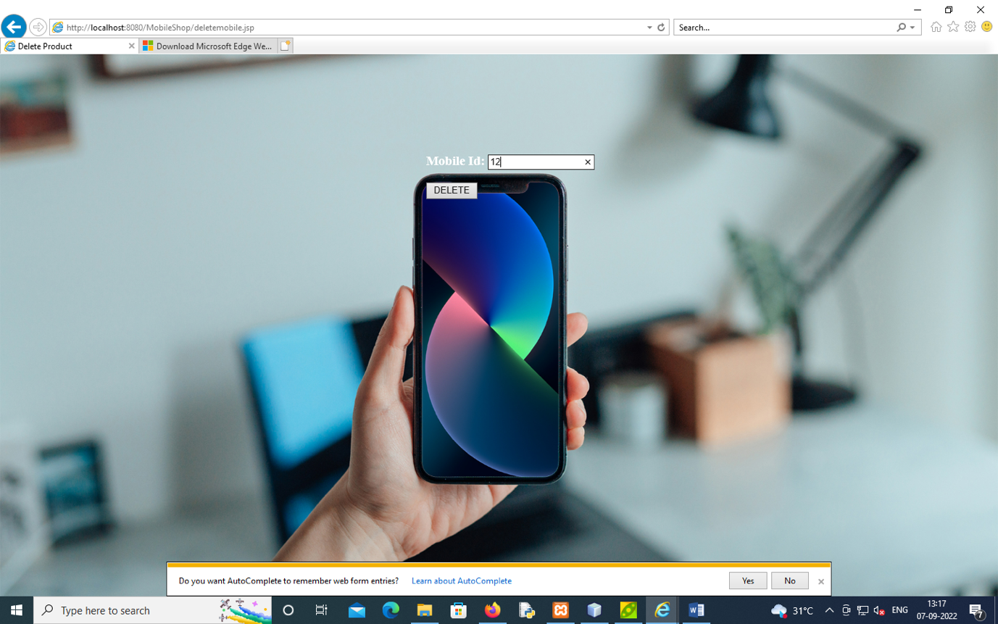

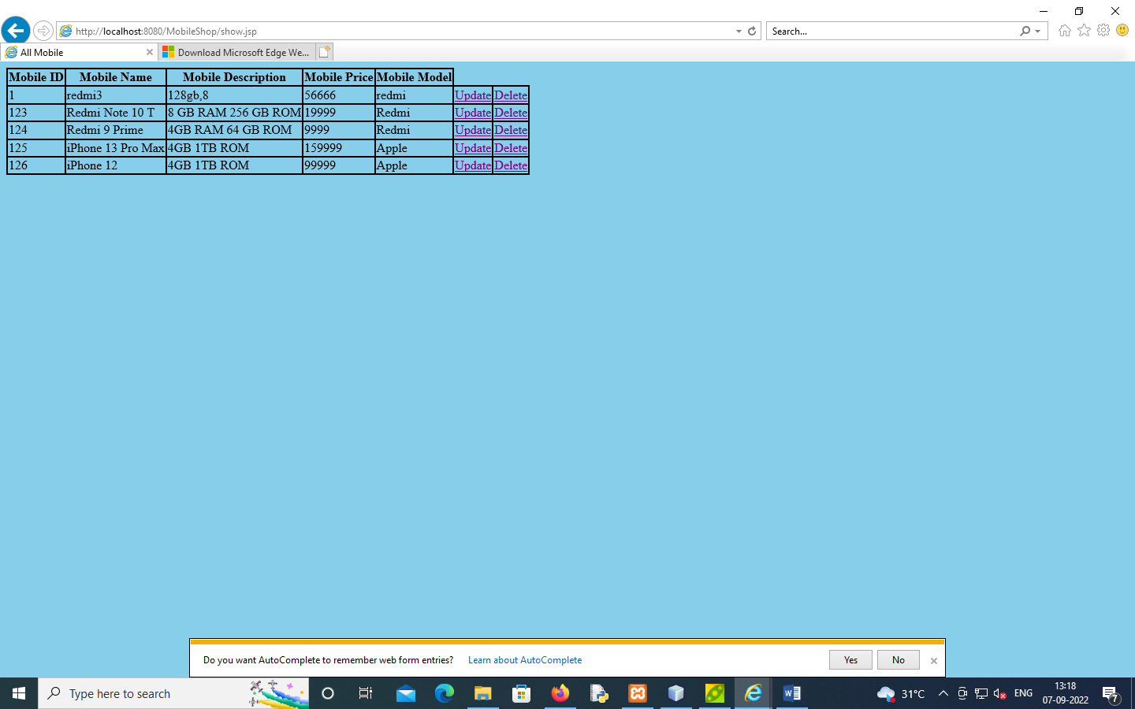

**SHOW ALL DETAILS**



THANK YOU